6 September 2023

CSRM Documentation - Overview

___________________________________________________________________________________

Below is an overview of CSRM Documentation

Items 1 – 4 are internal to the CSRM

Items 5 and 6 are relate to the self-documentation  
 of packages and package diagrams

Items 7 and 8 are external to the CSRM

**CSRM Documentation - Overview**

**1 - Overview and Navigation Package**

**2 - Reference Information Package**

**3 - Population Packages**

**4 - Examples and Illustrations Packages**

**5 - Example of Hovering a Cursor to Reveal Definitions and Descriptions**

**6 - Example of Using Comments to Provide: Explanation and How-To**

**7 - Papers and Presentations**

**8 - Memos**

Memos provide guidance in addition to the Explanation and How-To comments imbedded in the CSRM.

**CSRM Overview and Navigation Page**

xx

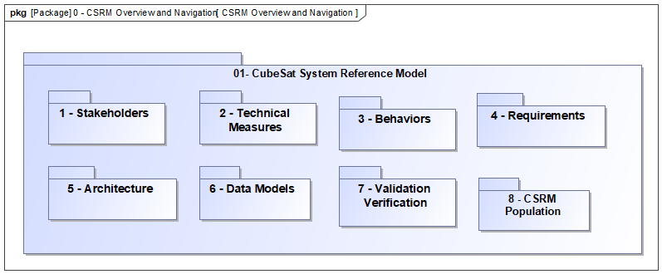

**1 - CSRM Overview and Navigation Package**

**CSRM Reference Information Package**

Use of these terms in the CSRM will be noted with an underline and hovering the cursor over a term exposes the definition of the term. The definition is populated in the documentation property of the term.

Additionally hovering over a package exposes the description of package,

xx

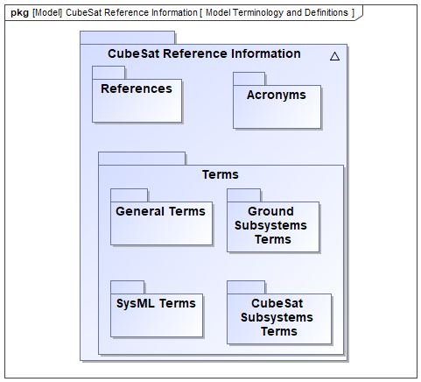

**2 - CSRM Reference Information**

**3 - CSRM Population Package**

The CSRM Population package is a centralized collection of all population packages.

Regulatory Agency Stakeholders and Concerns – Population

Mission Stakeholders and Requirements – Population

Technical Measures - Specifications and Requirements – Population

Behaviors - Use Cases - Activities – Population

Requirements Hierarchy –Population

CubeSat Rqts – Population

CubeSat Subsystems Rqts – Population

CubeSat Components Rqts – Population

CubeSat Subsystems –Population

CubeSat Components – Population

Ground Segment Rqts – Population

Ground Subsystem Rqts – Population

Ground Component Rqts – Population

Ground Subsystems – Population

Ground Subsystems Components – Population

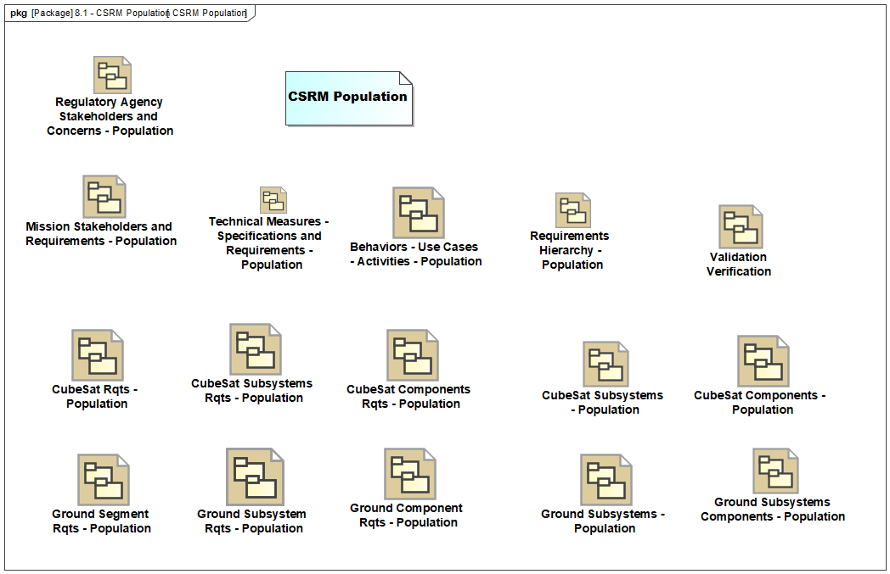xx

**4 - CSRM Examples and Illustrations – Packages**

The following will be gathered in a centralized collection – just like the above population packages.

Regulatory Agency Stakeholders – Example

Mission Stakeholders – Examples

Mission Stakeholders – Requirements, Technical Measures, Use Cases – Illustration

~~Mission Stakeholders Requirements Relationship – Example~~

Technical Measures – Specifications and Requirements – Illustration

~~Behaviors - Enterprise Level - Illustration~~

~~Collect and Distribute Mission Data – Example~~

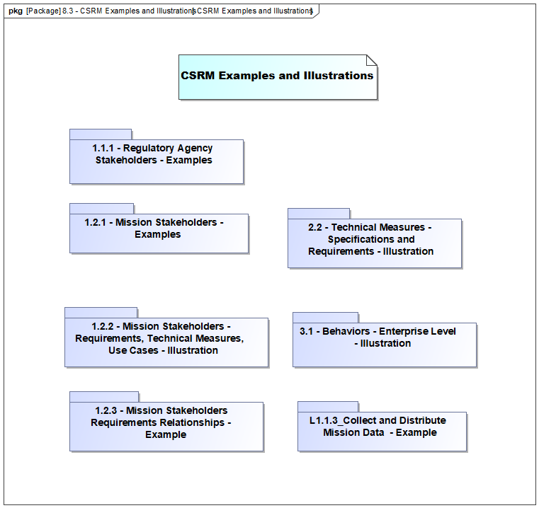

**4**

**8**

**1**

**2**

**5 - Example of Hovering a Cursor to Reveal Definitions and Descriptions**

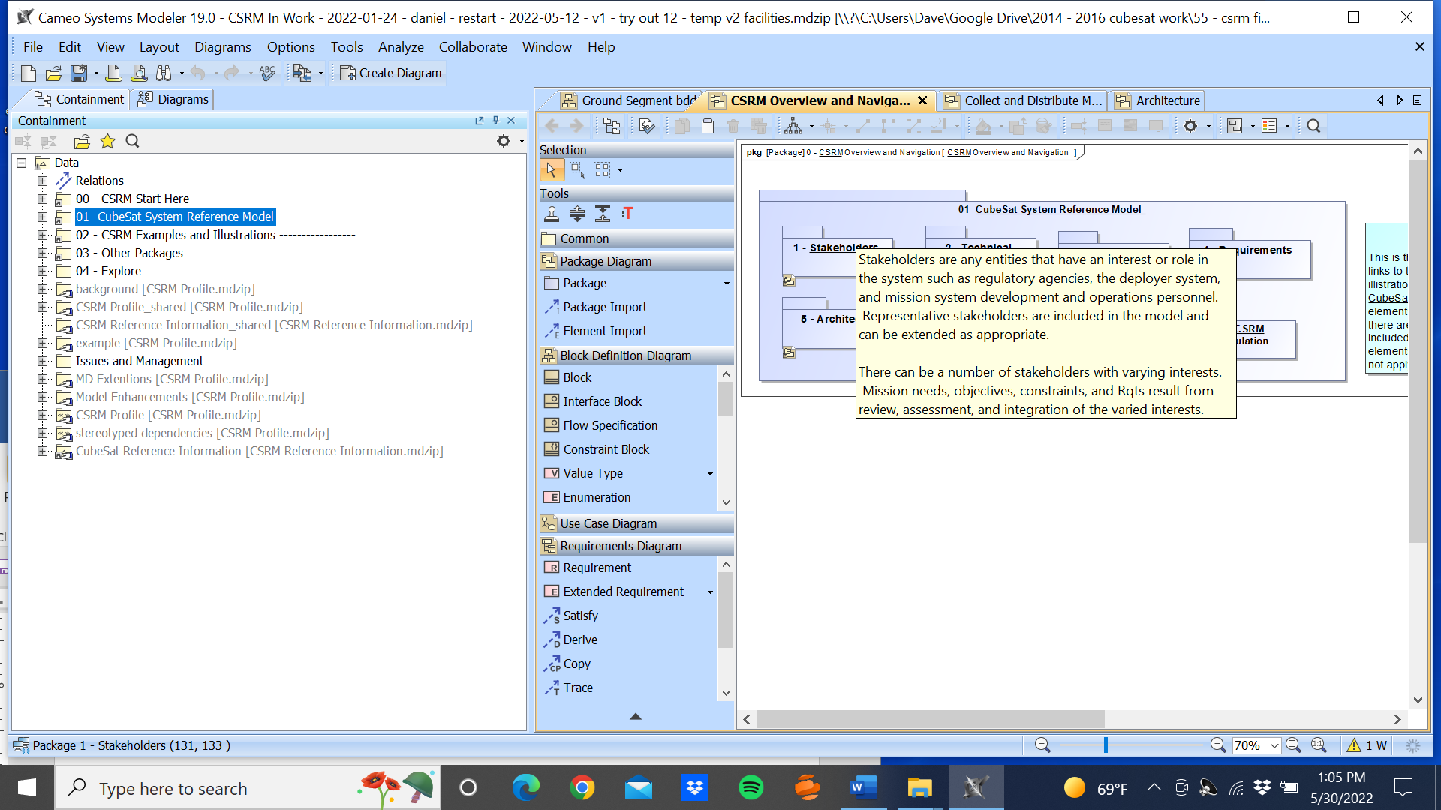

Hovering over the CSRM Reference Information term: Stakeholder

The underline denotes a CSRM Reference Information term

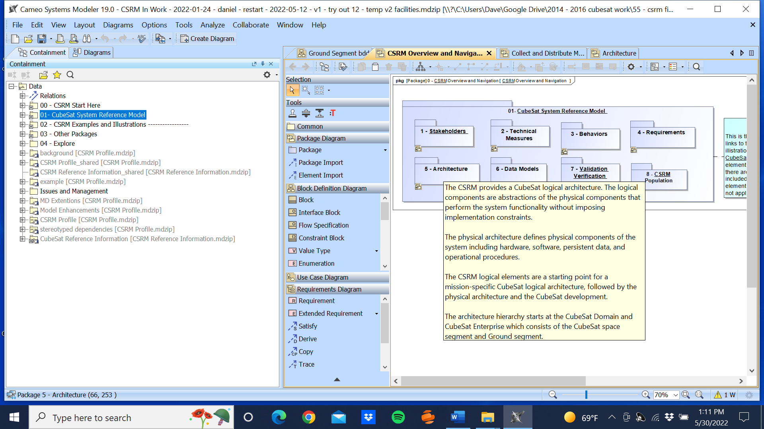

Hovering over package: 5 - Architecture

**Example of Using Comments to Provide: Explanation and How-To**

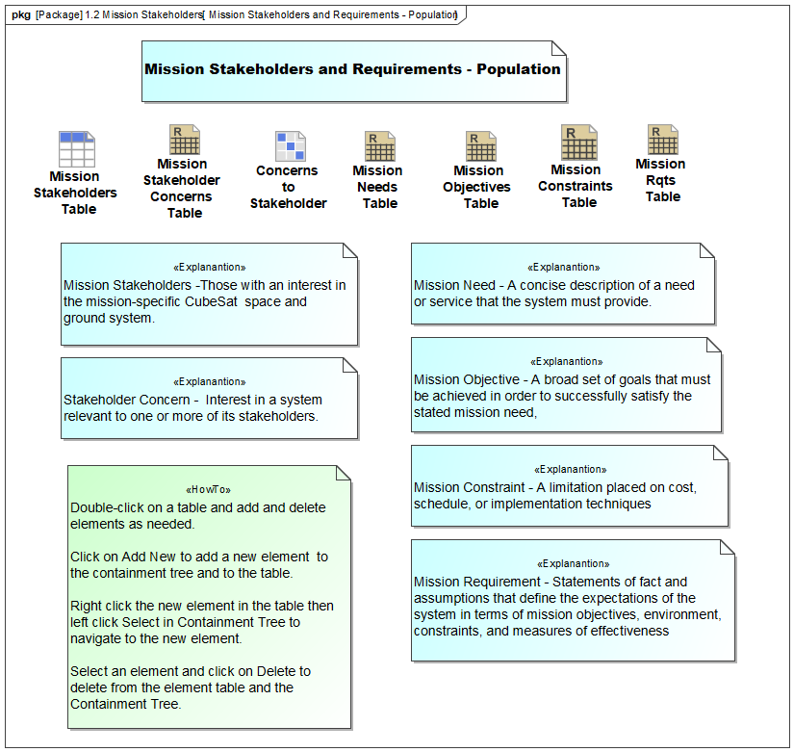

xx